**Benchtop Function Generators**

[**https://www.alibaba.com/product-detail/Hospital-Equipment-High-Flow-Oil-Free_1600194531436.html?spm=a2700.galleryofferlist.p_offer.d_image.5e136594PkSqvy&s=p**](https://www.alibaba.com/product-detail/Hospital-Equipment-High-Flow-Oil-Free_1600194531436.html?spm=a2700.galleryofferlist.p_offer.d_image.5e136594PkSqvy&s=p)

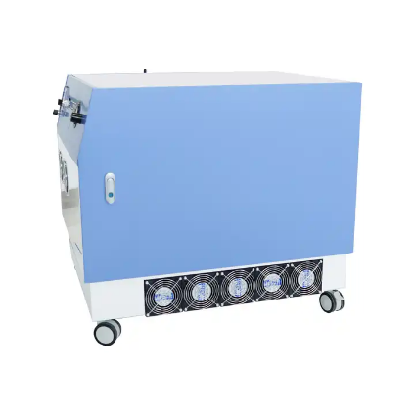**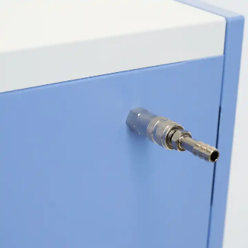Price:** >= 1 piece US$3,000.00 to US$3,300.00

**Product Name:** GAOTek PSA Oxygen Generator

**Product ID:** GAOTek-BFG-201

**Overview**: GAOTek PSA Oxygen Generator are mainly used for small hospitals and clinics. Especially they are suitable for hospital mini oxygen central system. Oxygen concentrators as oxygen source, let them connect to hospital equipment belt, they can support 10-30 patient beds.Usually we recommend to use the buffer tank betwen the beds and oxygen concentrators. That will make the oxygen supply more stable.

**Features :**

* Absolutely dry , clean and oil free
* Small and light weight , easy and safe to operate
* Simple, reliable and easy maintenance
* High flexibility, it is movable, can support oxygen for different quantity beds according to demands
* Energy saving, low power consumption
* Cost -Effective

**Technical Specifications:**

|  |  |
| --- | --- |
| **Flow rate** | 20 LPM |
| **Oxygen purity** | 93±3% |
| **Outlet pressure** | 0.14 Mpa to 0.4 Mpa |
| **Outlet pressure** | 0.14-0.4 MPA (20-60PSI) |
| **Noise level** | ≤60 db |
| **Power consumption** | ≤2000 W |
| **Size** | 34.64 in x 32.91 in x 31.49 in (880 mm x 836 mm x800 mm) |
| **weight** | 0.26 lb (118 kgs) |

<https://www.alibaba.com/product-detail/Hantek-HDG2062B-Benchtop-Generator-Signal-with_62193209081.html?spm=a2700.galleryofferlist.normal_offer.d_image.5e136594xXgNya>

**Price :** >= 1 to 9 pieces US$519.23

>= 10 to 49 pieces US$498.46

>= 50 pieces US$477.69

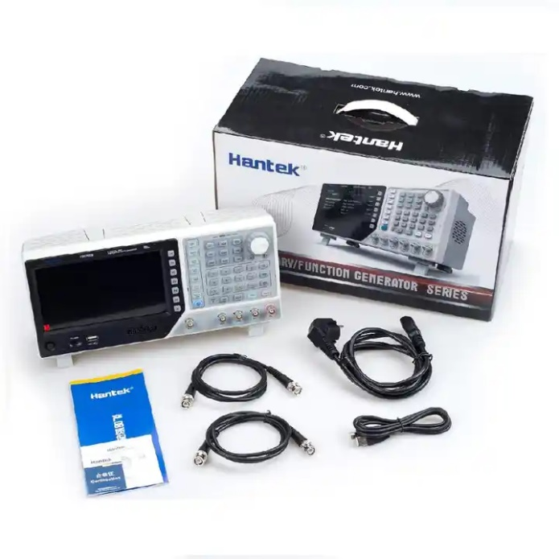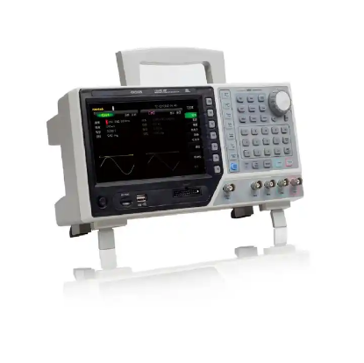

**Product Name:** GAOTek USB LCD Digital Function Generator

**Product ID:** GAOTek-BFG-202

**Overview:** GAOTek USB LCD Digital Function Generator has 16Bit Resolution, 250MSa/s Sample Rate; 64M Memory Depth.100/80/60/30MHz. Sine Output Frenquency.16 channels digital output, together with the analog channel can rebuild the more mixed signals in daily practice. Support AM, FM, PM, ASK, FSK, PSK and PWM modulations. TCXO timebase standard, OCXO optional for ultra-high stability.7 inch, 64K true color TFT display, WVGA(800X480).Plenty of interfaces: USB Host, USB Device, LAN.80M Frequency Counter.

**Technical Specifications:**

|  |  |
| --- | --- |
| **Channel** | 2 |
| **Waveform length** | 64 M |
| **Impedance** | 50 Ω |
| **Frequency Range** | 60 MHz |
| **Sample Rate** | 250 MSa/s |
| **Voltage resolution** | 16 Bit |
| **Frequency** | 1 Hz to 500 MHz |
| **Power Consumption** | <60 W |
| **Sine** | 1 uHz to 1 Max. |
| **Pulse** | 1 uHz to 15 MHz |
| **Square** | 1 uHz to 30 MHz |
| **Symmetry** | 0% to 100% |
| **Ramp** | 1 uHz to 4 MHz |
| **Dimension** | 13.77 in x 5.90 in x 7.08 in (350 mm x 150 mm x 180mm) |
| **Weight** | 8.81 lb (4.00 kg) |